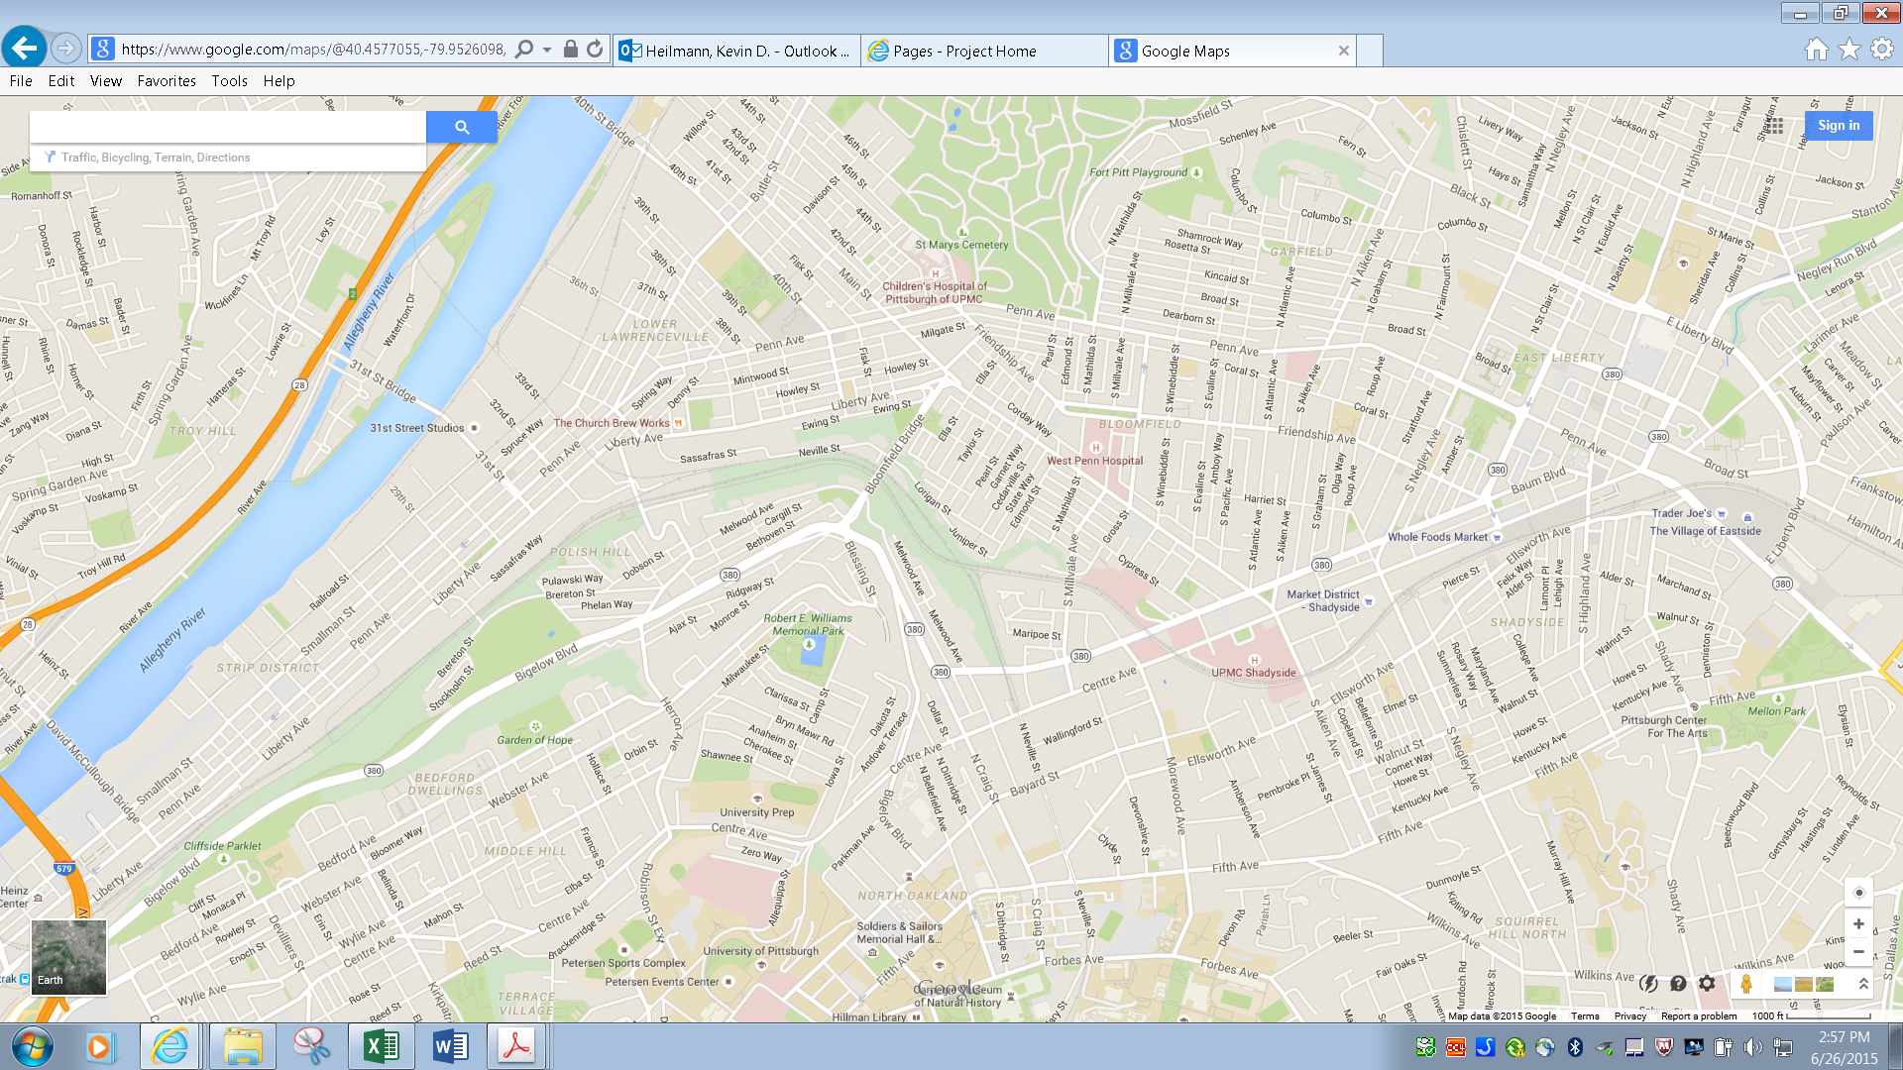

BIGELOW / BAUM BLVD. PROJECT